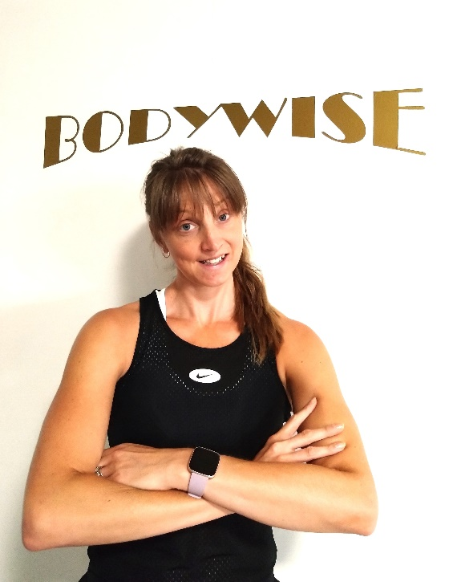
Pippa Bown
As a busy mum of 3 children, fitness has been a great way for me to de-stress, regulate and motivate me throughout my days.
Health and nutrition have always been a passion of mine, so I’m loving being part of the Bodywise team. It’s quite different from what I’ve done so far, as an early years and youth work leader, but having now completed my Level 2 Fitness qualification I’m excited about continuing my journey in this new adventure.
I am passionate about creating new, fun and challenging exercise workouts for all ages and abilities, allowing people to empower themselves to reach their full potential through encouraging and inspiring them to believe they can!
I look forward to seeing some of you in my fitness classes!

